UHLM1012 (Bahasa Malaysia Kominikasi 2) Semester 2, Sesi 2024/2025
KUIZ (20%)

NAMA: ______________________________ SEKSYEN: _________

Soalan A:
Isi teka silang kata di bawah. (10%)

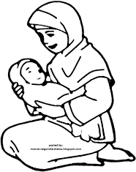
Melintang Menegak

1.  2.

5. 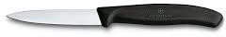 3. 
7.  4. 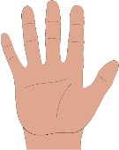

-  6. 

-  8. 
Jawapan:

10.
9.
8.
7.
6.
5.
4.
3.
2.
1.

Soalan B : Tulis nombor yang berikut dalam bentuk perkataan (5%)

- 90
________________________________________________________

- 68
________________________________________________________

- 3.27
________________________________________________________

- 72.8
________________________________________________________

- 45%
________________________________________________________

Soalan C : Ujian Penulisan (Writing Test) (5%)

Berdasarkan gambar di bawah, bina 5 ayat yang sesuai.
(Based on the picture below, make 5 sentences.)



 
 
 
 
 

